Seminar Announcement

9:00 a.m. ~ 12:00 a.m., January 19, 2017, Room: 107, GREAT

Title: High Energy-Efficient Cooperative Channels Allocation in Unlicensed Spectrum for D2D Assisted Cellular Networks
Dr. Taras Maksymyuk and Prof. Minho Jo

Abstract
Recent interesting activities in spectrum analysis have suggested an additional band 5 GHz unlicensed spectrum for LTE networks. 5 GHz unlicensed spectrum has been used for Wi-Fi. The new paradigm, known as LTE-Unlicensed (LTE-U: LAA and LWA), has shown a great potential to boost the capacity of 5G cellular networks. However, in most countries, implementation of LTE-U requires additional listen before talk (LBT) techniques to avoid interference between LTE-U and legacy Wi-Fi networks. Similar to conventional 802.11 protocol, LTE-U/LBT protocols perform quite well for the small number of users, whereas for the high number of users the bandwidth utilization decreases, which gives negative impact on the spectral and energy efficiency. In this work, we have developed a new approach for cooperative LTE-U/LBT for the case of D2D (Device to Device) assisted cellular networks. The main idea is to reduce the number of total LBT attempts for each user by their cooperation within the D2D cluster. Each cluster is formed by two or more devices in the vicinity of each other. The cluster devices sense the carrier occupancy alternately and share the obtained information with other cluster members. Thus, the number of sensing attempts will decrease proportionally to the number of users in a single cluster. To further improve the bandwidth utilization, cluster members configure the size of contention window to minimize the idle time between their accesses to the unlicensed channel. It means that if one cluster member wins the contention for the channel, other members will be the next winners for this channel according to the queue and without additional contest. Our proposed scheme allows to improve the energy efficiency as well as to increase the overall capacity of LTE-U cellular networks.

Biography
Minho Jo (SM’16) received the B.A. degree from the Department of Industrial Engineering, Chosun University, South Korea, in 1984, and the Ph.D. degree in computer networks from the Department of Industrial and Systems Engineering, Lehigh University, USA, in 1994. He is currently a Professor with the Department of Computer and Information Science, Korea University, Sejong City, South Korea. He is one of the founders of the Samsung Electronics LCD Division. Areas of his current interests include LTE-unlicensed, Internet of Things, cognitive networks, HetNets in 5G, green (energy efficient) wireless communications, mobile cloud computing, 5G wireless communications, optimization and probability in networks, network security, software defined networks, and massive MIMO. He received the Headong Outstanding Scholar Prize with price money of U.S. $20 000 in 2011. He is the Founder and Editor-in-Chief of the KSII Transactions on Internet and Information Systems [SCI (ISI) and SCOPUS indexed, respectively]. He is an Editor of the IEEE Wireless Communications, and an Associate Editor of the IEEE INTERNET OF THINGS JOURNAL, Security and Communication Networks, Ad-Hoc & Sensor Wireless Networks, and Wireless Communications and Mobile Computing. He is the Vice President of the Institute of Electronics and Information Engineers and was the Vice President of the Korea Information Processing Society.
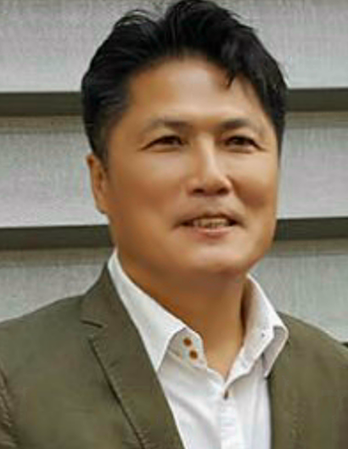
Taras Maksymyuk [M’14] (taras.maksymyuk.ua@ieee.org) is now an assistant professor in the Telecommunications Department, Lviv Polytechnic National University, Ukraine, and Research Professor in the Department of Computer and Information Science, Korea University, Sejong Metropolitan City, South Korea. He received his Ph.D. degree in telecommunication systems and networks in 2015, his M.S. degree in information communication networks in 2011, and his B.A. degree in telecommunications in 2010, all from the same university. He was recognized as the Best Young Scientist of Lviv Polytechnic National University in 2015. He is currently an Editor of KSII Transactions on Internet and Information Systems (SCI and SCOPUS indexed), and an Editor of International Journal of Internet of Things and Big Data. He is currently a member of the IEEE Communications Society and IEEE Software Defined Networks Community. His research interests include cognitive radio networks, LTE in unlicensed spectrum, mobile cloud computing, massive MIMO in 5G, machine-to-machine communication and heterogeneous network in 5G, software defined radio access networks, and the Internet of Things.
